Grounds for Extra Credit

Give users the option to:

1. Use the program in one of three supported languages:
   1. Arabic

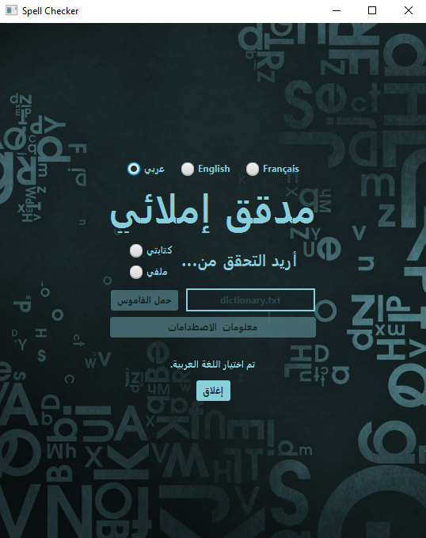

* 1. English

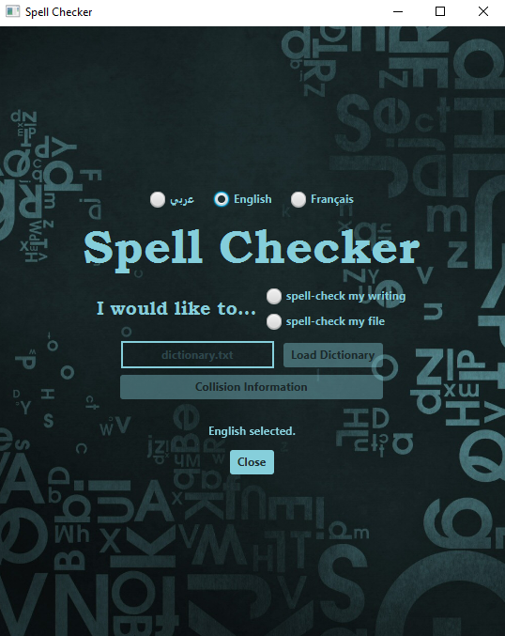

* 1. French

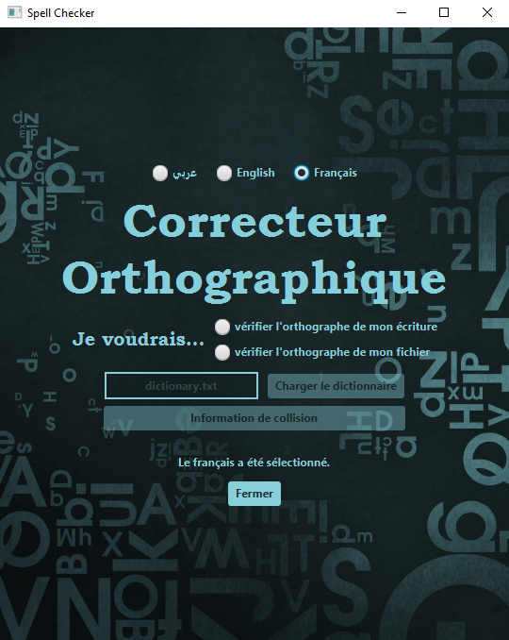

1. Enter the name of any file they would like to use as a dictionary

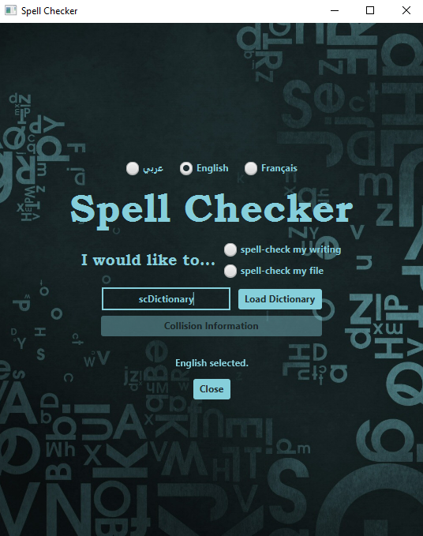

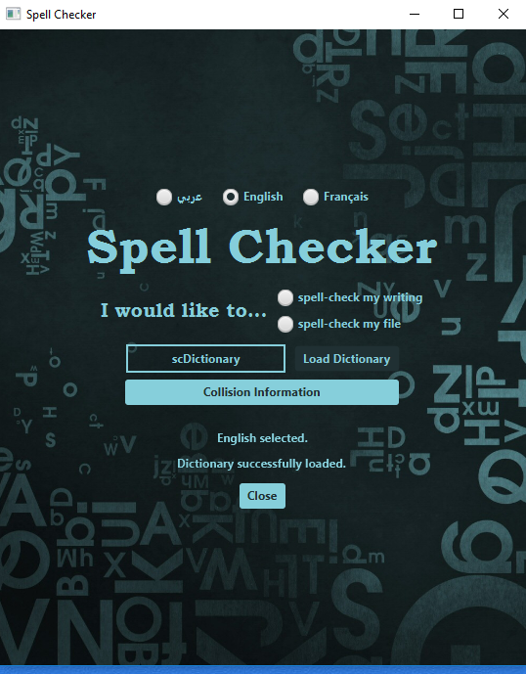

1. View the specified dictionary file’s collision information

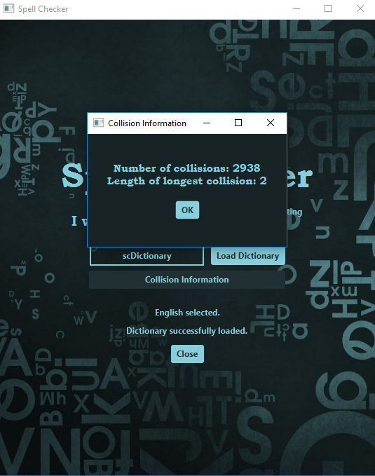

1. Spell-check their writing

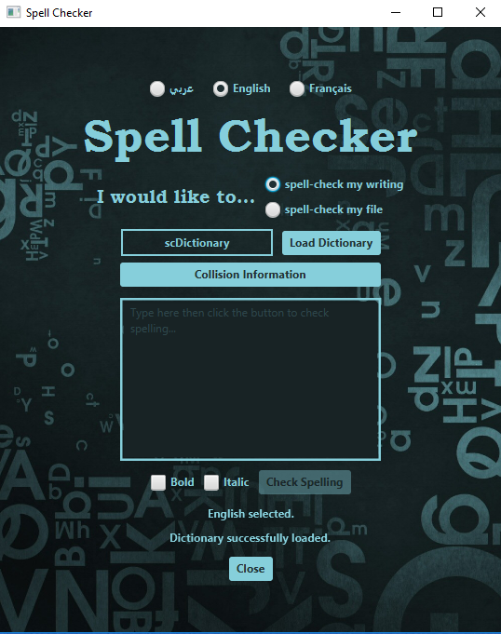

* 1. Type in bold and/or italic for better viewing purposes

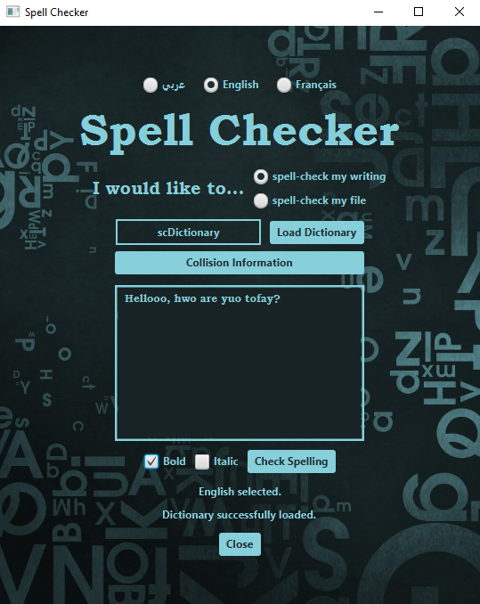

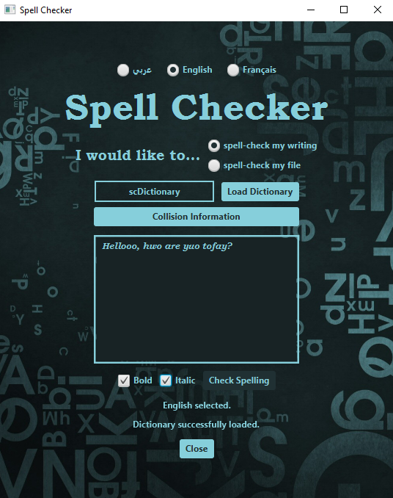

* 1. See their errors in red and view the number of errors and suggested replacements for each word

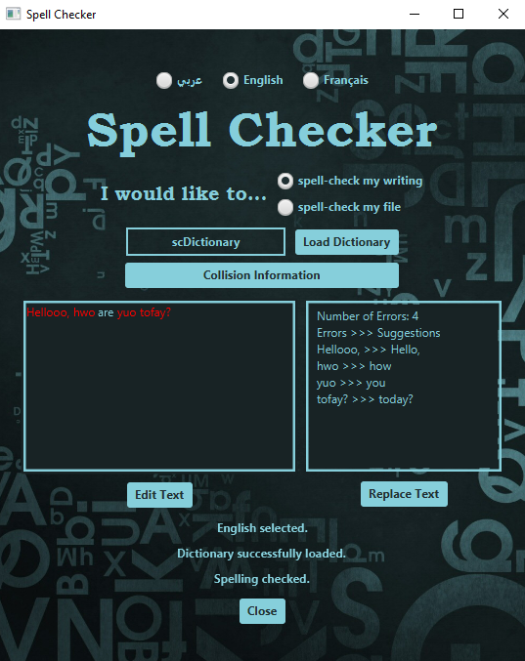

* 1. Replace their original text with the suggestions displayed

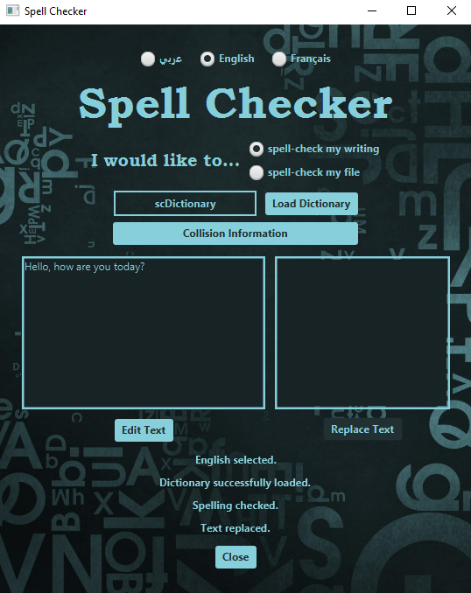

* 1. Continue to edit their text, re-check their spelling, etc…

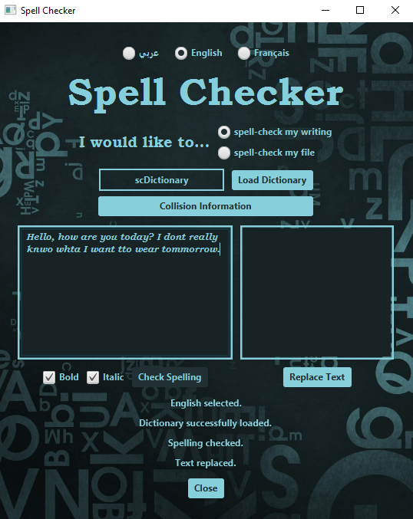

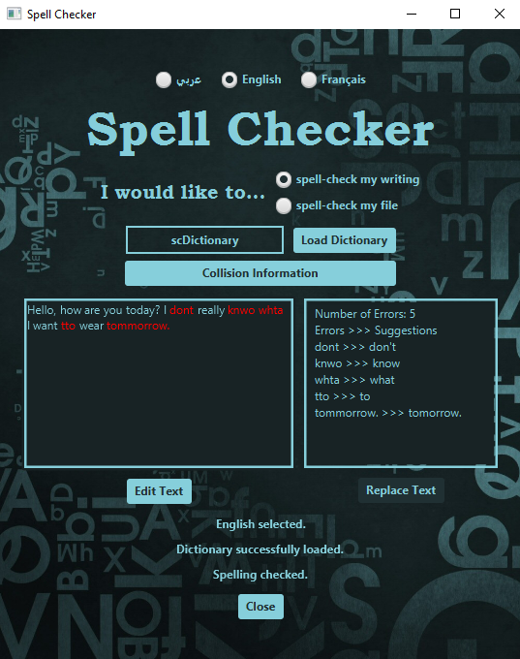

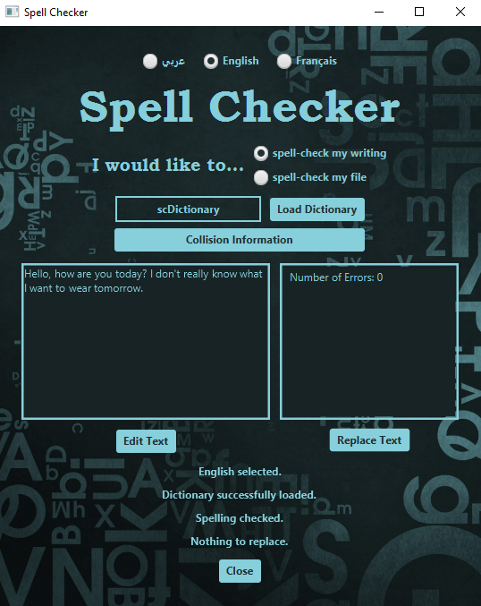

1. Spell-check their file

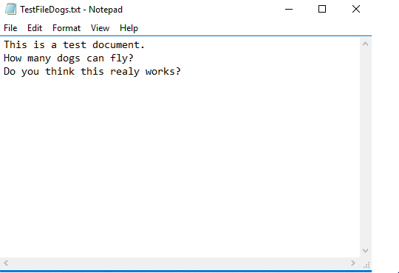

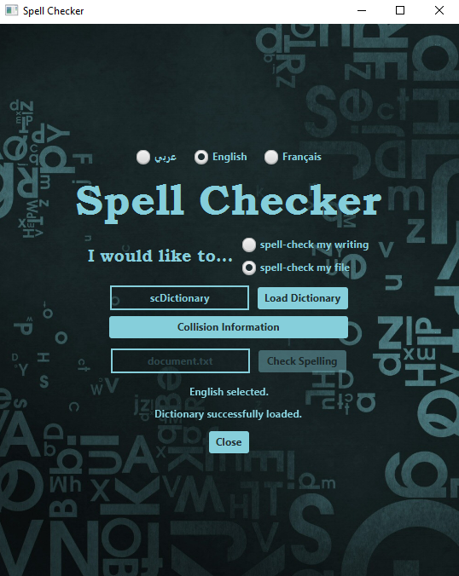

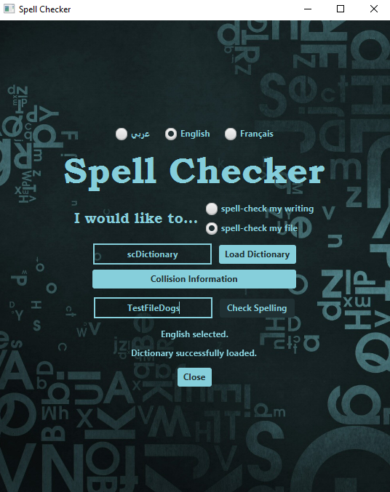

* 1. View their file within the program for their convenience as well as the number of errors and suggested replacements for each word

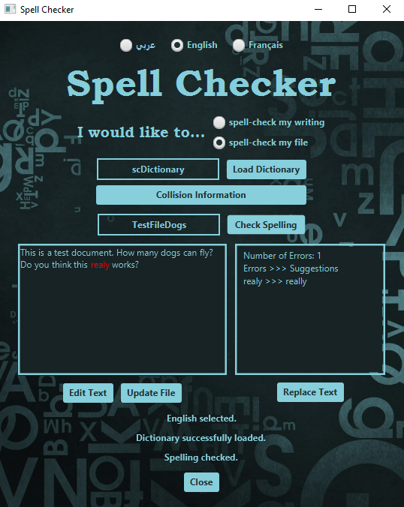

* 1. Edit and/or replace the text in the file and continue to edit their text, re-check their spelling, etc…

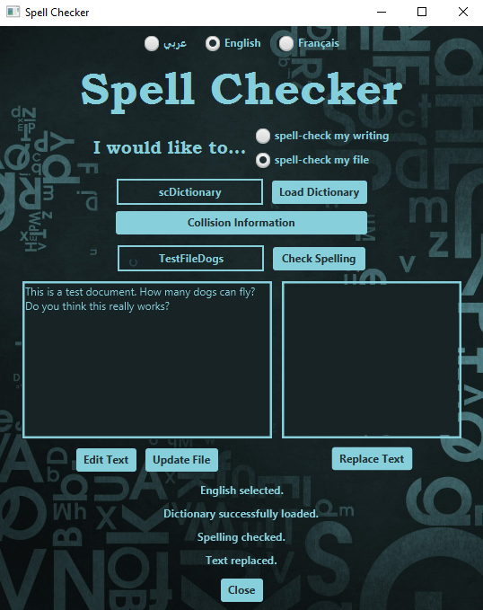

* 1. Update the text in the file

